NATIONAL UNIVERSITY OF SCIENCES & TECHNOLOGY


Degree: MS-Bioinformatics
Department: School of Interdisciplinary Engineering & Sciences (SINES)
Submitted to: Dr. Masood Ur Rehman Kayani
Project No: 02

Student name: Mahreen Nawaz
Registration No. 533241
Subject: Next Generation Sequencing
Topic: Differential gene expression analysis of Crohn's disease using R.
Submission Date: 8th December 2024

- Data analysis strategy:
Overview:
Crohn's disease (CD) is a chronic (long-lasting) disease that causes inflammation in the digestive tract. The RNASeq data of ileal biopsies from pediatric CD patients and controls were provided. The results were obtained after mapping the processed reads to the human reference genome (Ensembl release: 95) using HISAT2, and subsequent generation of count-matrix using FeatureCounts2. We perform differential gene expression analysis using R.
Overview of the data:
Total samples: 304
Total genes in the counts file row wise : 65217
In the dataset of 304 Samples there are 50 Control, and 254 Diseased. I renamed the column category Crohn's disease as disease and non-inflammatory bowel disease control as control. There are 6 columns in the metadata file named Sample, Age at diagnosis, category, Sample source and gender and 304 rows showing samples.
DESeq2 object:
For the DESeq2 analysis we create DESeq2 object named as dds.
dds = DESeqDataSetFromMatrix(counts,metadata,~Category)
dds stands for DESeq DataSet, which is an object of the DESeqDataSet class. This object acts as a container for the count data, metadata, and experimental design needed for differential expression analysis. It will be used in subsequent steps of the analysis.
DESeqDataSetFromMatrix()
This function initializes the DESeqDataSet object from:
- A matrix of raw count data (counts).
- Metadata describing the samples (metadata).
- A formula defining the experimental design (~Category).
It prepares the data for normalization, dispersion estimation, and statistical analysis.
Input Arguments:
counts
A matrix of raw read counts obtained from RNAseq, where:
Rows: represent genes.
Columns: represent samples.
The data here in unnormalized. DESeq2 handles normalization internally.
Metadata
- A data frame that contains sample-level metadata (also called column metadata).
- Each row corresponds to a sample in the counts matrix, and columns describe experimental variables or conditions.
- Sample: Identifiers for each sample it include sample IDs.
- Category: A variable describing the experimental condition (as “Control” or “Disease”).
~Category
- The design formula, which specifies the experimental factor(s) of interest influencing gene expression.
- In this case:
  - Category is the grouping variable (as “Control” and “Disease”).
  - The ~ operator defines a formula in R. It tells DESeq2 to model gene expression differences based on the Category variable.
Sample-sample distances using PCA:
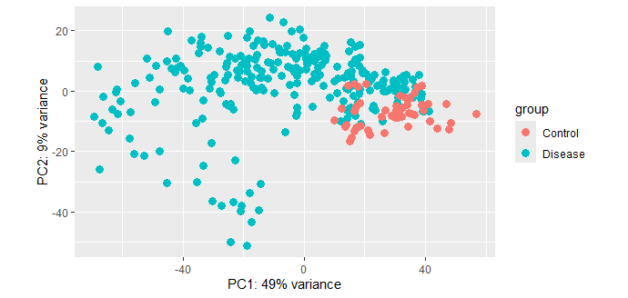
Figure 1. PCA plot showing sample-sample distances
Axes (PC1 and PC2):
PC1 (Principal Component 1): The x-axis shows the direction of maximum variance in the data, explaining 49% of the variance.
PC2 (Principal Component 2): The y-axis shows the second most important direction of variance, explaining 9% of the variance.
Together, these two principal components represent a large portion of the variation in the dataset.
Points:
Each point represents a single sample from the RNAseq dataset.
The position of a point reflects how similar or different the sample’s gene expression profile is to others.
Color Coding (Groups):
Red points represent samples labeled as “Control.”
Blue/Teal points represent samples labeled as “Disease.”
Conclusion:
This PCA plot provides a high-level overview of how samples are related based on their gene expression. The distinct clustering of "Control" and "Disease" samples indicates that the experimental condition (disease state) significantly influences gene expression, making it a key factor for further analysis.
- DESeq2 Analysis:
Input Data
- Count Matrix: Rows are genes, columns are samples, and values are raw read counts.
- Metadata (colData): Includes information about the experimental conditions (as control and disease).
Creating DESeq2 object:
R code:
dds = DESeqDataSetFromMatrix(counts,metadata,~Category)
The above R code is used to create dds object which Store all the input data to be used in downstream steps like normalization, statistical testing, and visualization etc.
Normalization
DESeq2 normalizes raw counts to account for differences in sequencing depth and library sizes between samples.
Normalization is based on size factors, which are estimated using the median ratio method.
Dispersion Estimation
DESeq2 estimates the variability (dispersion) of gene expression across biological replicates.
This step models the relationship between mean expression and variance, which is crucial for accurate differential expression analysis.
Differential Expression Analysis
DESeq2 fits a generalized linear model (GLM) for each gene, comparing conditions while accounting for dispersion and normalization factors.
Statistical significance is tested using the Wald test or the likelihood ratio test (LRT) for complex designs.
Output:
Outputs of DESeq2
- Differential Expression Results
  - For each gene, DESeq2 provides:
    - log2FoldChange (log2FC): Magnitude of expression change between conditions.
    - p-value: Raw significance of the test.
    - Adjusted p-value (padj): Corrected for multiple testing using the Benjamini-Hochberg method (False Discovery Rate, FDR).
The outputs of DESeq2 enable us to identify biologically meaningful patterns and genes with significant changes in expression under experimental conditions.
R Code used for setting stringent threshold:
res.01 <- results(dds, alpha=.01)
summary(res.01)
lfc2res.01 <- results(dds, alpha=.01, lfcThreshold=1)
summary(lfc2res.01)
Summary of the output of DESeq2 in table 1 and 2.
Table 1 Default p-value
54856 read count  P-value <0.1 | Gene count | Percentage
LFC>0 (Up) | 5976 | 11%
LFC<0 (down) | 7413 | 14%

Table 2. p-value 0.01
54856 read count  P-value <0.01 | Gene count | Percentage
LFC>0 (Up) | 398 | 0.73%
LFC<0 (down) | 20 | 0.036%

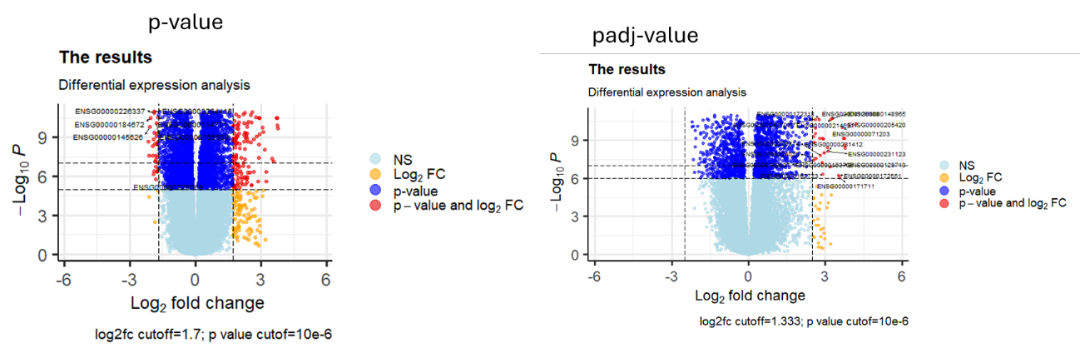
Figure 2. Volcano plots of p-value and padj-value

Axes and Key Features:
X-Axis (Log2 Fold Change):
Represents the magnitude of differential expression between the two conditions.
Positive values indicate upregulated genes (higher expression in one condition).
Negative values indicate downregulated genes (lower expression in one condition).
Y-Axis (-log10(p-value)):
Represents the statistical significance of the genes.
Higher values indicate more statistically significant results (smaller p-values).
Key Thresholds
Log2 Fold Change Cutoff:
Genes with |log2FC| > 1.7 and 2.5 are considered to have biologically meaningful changes in expression.
P-value and padj Cutoff:
A very stringent threshold of p-value < 10e-6 and 10e-7 (p-value and padj) has been applied, ensuring high confidence in the identified genes.
Color Coding:
Light Blue (NS - Not Significant):
Genes that do not meet either the p-value or log2FC thresholds.
Orange (Log2FC):
Genes that meet only the log2FC threshold but not the p-value threshold.
Blue (P-value):
Genes that meet only the p-value threshold but not the log2FC threshold.
Red (Significant):
Genes meeting both thresholds (|log2FC| > 1.7 and 2.5 and p-value and padj < 10e-6 and 10e-7).
These are the differentially expressed genes (DEGs).
Key observation:
A significant number of genes are in the red category, indicating strong differential expression.
Genes that only meet one threshold (blue or orange points) might be of moderate interest but are less reliable due to weaker confidence or smaller effect sizes.
3 Geneset Enrichment Analysis (GSEA)
After performing Deseq next step is Geneset Enrichment Analysis using the HALLMARKS classification from the MSigDB Dtabase.After performing GSEA following plot was obtained.
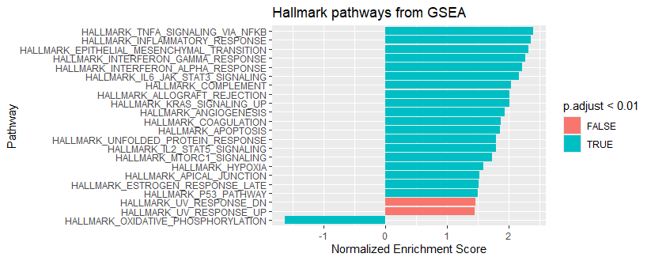

Figure 3. In this figure first three sea green lines on left shows positively enriched pathway and last sea green line in bottom show only one negatively enriched pathway .
First Positive Enriched Pathway
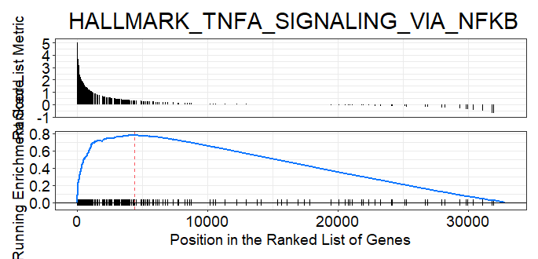

Second Positive Enriched Pathway
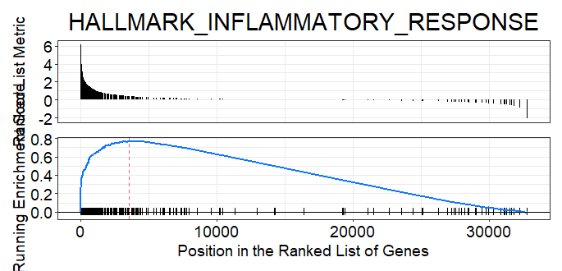
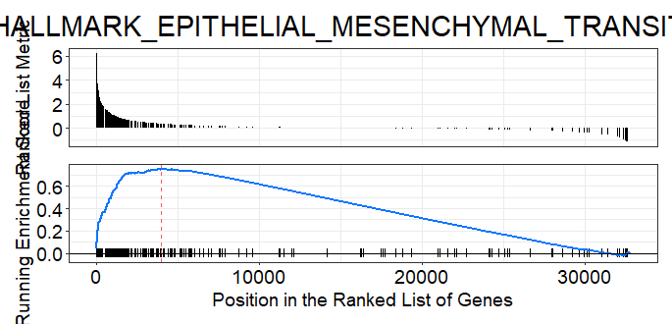
Third Positive Enriched Pathway
Negative Enriched Pathway
